Contents

Intro 2

SYSTEM SETUP 3

Note: Reset Button 3

Controller Setup(Optional) 4

Wired controllers 4

Configuring USB controllers 4

USB Keyboard 7

Wireless Controllers 7

Add a PS3 Controller 7

Add a PS4 Controller 7

Removing PS3, PS4 and other Bluetooth Controllers 8

Xbox360 Controllers 8

Other Controllers 8

Wifi Setup(Optional) 9

**CONTROLS** 9

Emulation Station 9

Runcommand Prompt 9

In game 10

**RetroArch Hotkeys Combinations and Saving/Loading games** 10

General Keyboard Controls 11

Atari5200/80 11

Arcade games 12

N64(Mupen64Plus) 12

Dreamcast(Reicast) 12

PSP(lr-ppsspp) 12

PSP(ppsspp) 12

**TRANSFERING ROMS** 13

Connect 13

Add your games 14

Arcade games 14

Get Romset 15

Scan Romset 15

ADDING BIOS 15

Check BIOS(Optional) 15

Windows 15

SSH RetroPie/ Linux / MacOSX : 16

**BIOS and ROM table** 16

PLAY! 20

Shutdown 20

Troubleshooting 20

Game Not Starting 20

Solutions 20

Updating RetroPie 21

Freezes 21

Reset 21

RetroPie Menu 22

Additional Configuration 22

Using Scraper to capture ROM box art and info 22

SSH Login 22

N64 Emulator Script 22

Notepad++ 23

RetroPie Configuration Utility 23

# Intro

The following instructions are my concise version of the [RetroPie Github](https://github.com/recalbox/recalbox-os/wiki/Home-%28EN%29) documentation.

The RetroPie Console is a system that will allow you to play 31 retro game consoles ranging from Atari 800 to Dreamcast. It runs on a micro computer called the Raspberry Pi, and uses a set of optimized emulators. Included with this Game Console are 31 pre-configured, speed optimized emulators. The Console have been verified working 1000’s of games 15 systems need bios files downloaded. See details in BIOS and ROM table.

Note: For copyright reasons, official system ROMs and BIOS file need to be downloaded separately and cannot be included with my setup. However, these instructions make it very easy to do so.

The **bold words** are for skimming the instructions for advanced users. The hightlighted text are **hyperlinks** to **other sections** and other **RetroPie related web links**.

# Setup

## Existing SD card and Retropie Pi Image

If you already have a Retropie image on an SD card, just open the case by removing the screws from the bottom with a Philips screwdriver. Pop open the case slightly and slide to the right to avoid the USB and HDMI cable about the screw mount. Plug the SD card in, with pins facing down, to the slot on the back of the Raspberry pi board. You may need to use needle nose pliers or tweezers to clear the cooling fan. Close the case back up.

## New SD card

If you are installing a new image, see the RetroPie Installation Preparing the SD card section, then continue from here. Plug the SD card with the new image into the case and

1. Place Emulator in a convenient place near a television/monitor with HDMI and next to an AC outlet.
2. Plug in included USB power adapter to the wall outlet and the microUSB end to the back of the Emulator case.
3. Plug in an HDMI cable from the Television/monitor to the back of the Emulator case.
4. Plug in a bluetooth dongle if one is included
5. Plug in 1 to 2 USB controllers and optionally a USB keyboard if you have one and are doing additional setup. If you are adding your own controllers, plug them in now. Setup is covered in the Controller Setup section. **Some emulators need Analog Sticks/Dual Shock functionality controllers to access all the controls. These currently include N64, Dreamcast, and Playstation 1.**

6. If you are uploading ROMS from your network or downloading Box Art with the Scraper Utility(See Scraper section below), you will need an internet connection to the Game Console. Open the RetroPie Console case front lid flap and plug an Ethernet internet connection from a Modem/Router to the Ethernet jack next to the USB slots or see the [Wifi](#_Wifi_Setup(Optional)) section to setup wifi after the Console starts.

7. Press in the left Power button on the front of the Game Console case. The red light will blink 2 times then remain solid.

### Note: Reset Button

**Note: DO NOT press the POWER button to shut the console off even if a game freezes and the controller isn’t responding. Instead, while the Raspberry Pi is running, hold the right RESET button on the game console for 2 to 4 seconds to restart the console; THE LIGHT WILL BLINK RAPIDLY. If this fails, holding the buttons for more than 4 seconds will issue a shutdown command; THE LIGHT WILL BLINK SLOWLY. Once all the light on the board are off. It is safe to press the power button. This avoids corrupting the SD card by pressing the POWER button while Emulation Station is reading/writing to the SD card. If this happens, however, an automatic repair will happen at next reboot.**

6. You should first see a RetroPie splash screen, followed by the frontend Emulation Station system screen. You can select your systems, launch your games, or access the configuration menu from here.

The first screen is the system screen :

[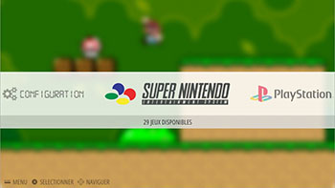](https://github.com/digitalLumberjack/recalbox-os/blob/master/wiki/images/emulationstation.jpg)

It shows all available systems.

# Raspberry Pi Installation

## Preparing the SD card

On windows

# Custom script installation

# Controller Setup(Optional)

If your system came with controllers, they will already be set up and working. To change or add controllers (For a list of compatibile controllers see [RetroPie Compatibility](https://github.com/recalbox/recalbox-os/wiki/Compatibility-%28EN%29#pad-controller)), see the section below. Use the pictures as a reference when your prompted to press buttons on the controller:

## Wired controllers

If you have an XBox360 wired USB controller, just plug it in and play! See the XBox360 controller button reference below.

## Configuring USB controllers

With the controllers connected and **EmulationStation** up, if you see a **“No game pads detected” window** try **pressing the PS3 button and other buttons** to check to see if they are already working. **If not, HOLD A**. You will see the controller name. Follow the instructions and use the pictures below to configure your controller(s). Pass any buttons you don't have by pressing a button set previously for 2 seconds.

Note:

Buttons assignment is based on the Super Nintendo controller. The L and R buttons (with L2 R2 L3 R3) are based on Playstation controllers.

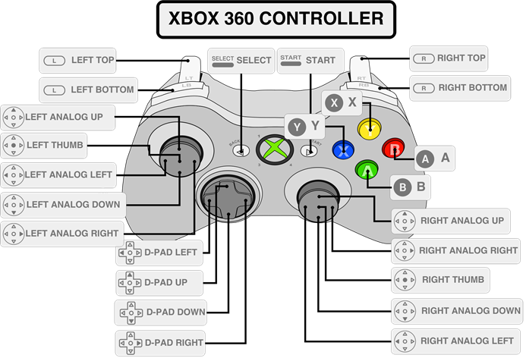

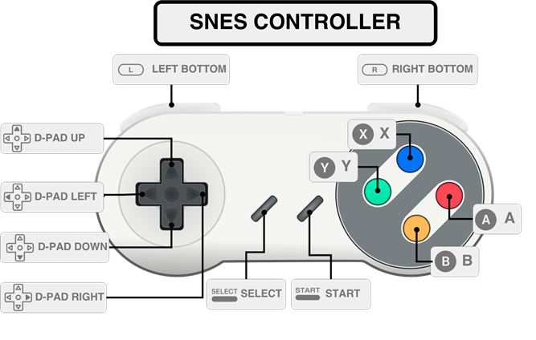

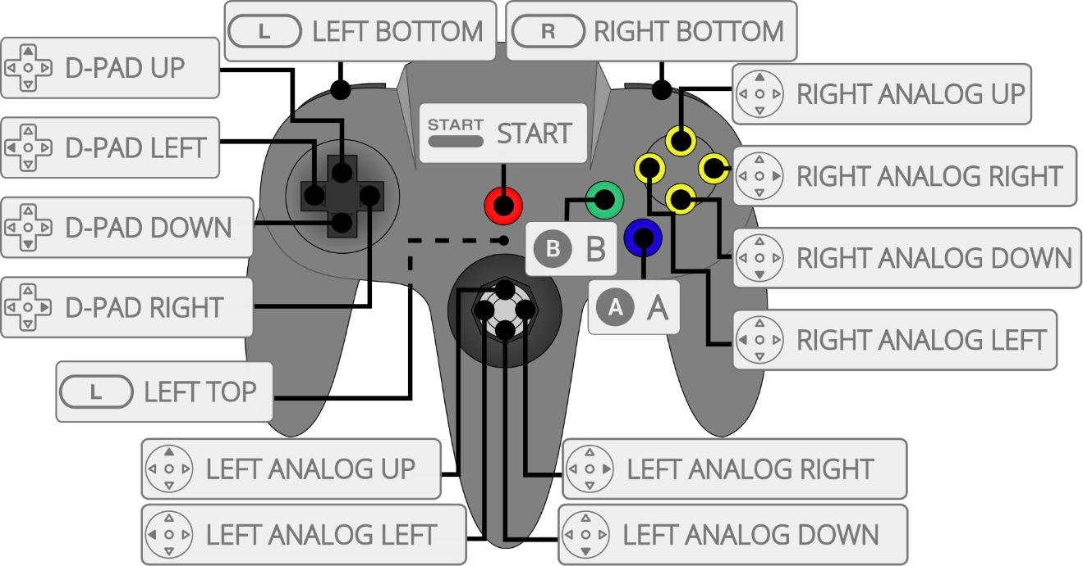

## USB Keyboard

If you have a USB Keyboard, Q is **START**, E is **SELECT**, D is **B**, A is **A.**

Navigate with the **Arrow keys**. And use **Enter** to select in the Runcommand prompt.

## Wireless Controllers

**NOTE**: Currently Raspberry Pi 3 and RetroPie 4 need a Bluetooth dongle to work with wireless Bluetooth controllers. The Console comes with a Bluetooth dongle. The onboard Raspberry Pi 3 bluetooth is not yet supported.

If your system came with wireless controllers, they will already be set up and working. To start, after EmulationStation starts, press the corresponding **Home/PS/Select** button turn on the controller. When the light is on, press a button to connect the controller. Continue below to change or add controllers

### Add a PS3 Controller

Note: be sure your PS3 Console is off while pairing controllers to RetroPie or it will try to sync with the PS3 console. Also I have switched the A and B buttons from the diagram below to correct the controls.

You cannot charge the PS3 controller wired to the console. You must charge controllers from a USB/AC power cord. **Plug the controller into the console and** **wait 10 seconds** to associate your controller with your console.

**Unplug the controller and press the PS3 button. Repeat for any additional controllers.**

### Add a PS4 Controller

Note: be sure your PS4 is off while pairing controllers to RetroPie or it will try to sync with the PS4 console

Put the PS4 controller into pairing mode by holding down the SHARE button & the PS button. You will have to setup the controller the 1st time you get to the first menu(Just Once). You can turn the controller off by holding down the PS button for about 10 seconds. You can then turn it back on any time you want. See advanced configuration [here](https://github.com/retropie/retropie-setup/wiki/Setting-up-a-PS4-controller)

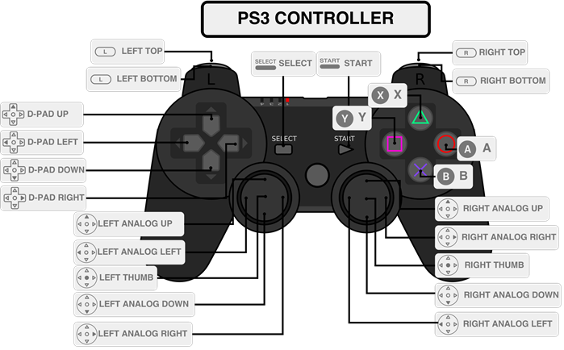

### Removing PS3, PS4 and other Bluetooth Controllers

From **EmulationStation**, scroll through the emulator to the RetroPie Menu. Select Bluetooth and press A. From the Runcommand prompt, select **Remove Bluetooth Device**. Select the controller(s) you want to remove and select with **SELECT**.

### Xbox360 Controllers

If you have an XBox 360 wireless controller and adapter you’d like to add to Retropie, the configuration will need edited. This requires some Linux skills such as connecting to RetroPie via SSH or directly with a USB keyboard and editing the configuration files. Further details can be found [here](https://github.com/retropie/retropie-setup/wiki/Setting-up-the-XBox360-controller)

### Other Controllers

See <https://github.com/retropie/retropie-setup/wiki#controller-configurations> for more controller options such as generic Bluetooth, Logitech and Smartphone virtual controllers.

# Wifi Setup(Optional)

Scroll through the **Emulator List** in **EmulationStation** until you see the **RetroPie Menu**. Press **A**. Scroll down to **WIFI** and Press **A**. Follow the onscreen prompts. See [here](https://github.com/retropie/retropie-setup/wiki/Wifi) for further details.

# **CONTROLS**

## Emulation Station

**A → Select  
B → Back  
Start → Main Menu (reboot menu)  
Select → Options  
R → Next Page  
L → Previous Page**

When you select a system with **A**, the screen will change and show all available games. Select a game with **A** again.

### Runcommand Prompt

When you see the dos-like bluescreen prompts, the controls are a little different. These come up when you **edit a game/emulator run settings** or are in the **RetroPie menu** in **EmulationStation.**

The controls are **Left Analog stick** to navigate and the **SELECT** button to select.

To edit a game/emulators run settings

1. From emulationstation and the emulator/game you want to configure, Press A to launch the game
2. Immediately press A or another button to open the RunCommand prompt window. Scroll through with D-pad or Analog and select an option with the Select button.
3. Selectable options are

1. Select default emulator for <system> - all games use selected emulator

2. Select emulator for rom – current rom uses selected emulator

4. Select default video mode for <system> - set resolution for system

5. Select video mode for <system> + rom - set resolution for current rom

8. Select render res for <system> - match resolution or try a lower value for better performance

X Launch

Q Exit

## In game

The **HOTKEY** is a button that will activate button combinations. The default hotkey button is **SELECT**.

### **RetroArch Hotkeys Combinations and Saving/Loading games**

**Press the HOTKEY(SELECT) followed by a button below for the desired command:**

**R2 → Save Game(look for a save message in the lower left hand corner)  
L2 → Load Game(look for a load message in the lower right hand corner)**

**Start → Quit Emulator  
B → Reset Game  
Y → RGUI Menu(Pause) – Can be used to change Controls from -> Quick Menu -> Controls  
Up → Select Save Slot -1  
Down → Select Save Slot +1  
Right → Speedup game  
Left → Rewind (if activated in Emulation Station options)**

**RetroArch hotkeys work with any emulator that starts with an “lr-“.**

**Save games in Dreamcast, Playstation 1 and PSP by using the internal system save settings, i.e. from the START/SELECT menu in the game the same way as on the original consoles. These saves are more stable than the RetroPie system saves(SELECT + R2). The RetroPie saves can be used on these systems for temporary game saves while in the same game session.**

### General Keyboard Controls

If you have a USB Keyboard plugged in, you can use these if you have issues with an emulator or Emulationstation controls.

**F1, Esc, Tab – Options Menus and Exits emulators**

**Ctrl-C – Kill Emulator and return to EmulationStation(works sometimes)**

### Atari5200/80

The [Atari800-rpi](https://github.com/jfroco/atari800-rpi) emulator is a derivative version of the RetroPie included Atari5200 emulator but with support for joypads.

**Joypad Controlls**

When prompted to **Select Cartridge Type**, scroll to option 3, 4, or 5 to see if those work first. Try the others as working alternatives for some games.

**Press the HOTKEY(SELECT) followed by a button below for the desired command:**

**R2 → Save Game(look for a save message in the lower left hand corner)  
L2 → Load Game(look for a load message in the lower right hand corner)**

**Start → Quit Emulator  
B → Reset Game  
Y → Emulator Menu(Pause) – Can be used to change Controls**

**KeyBoard Controlls**

Start Game: F4

Up: up or numpad 8

Down: down or numpad 2

Right: right or numpad 6

Left: left or numpad 4

Fire: RCTRL

Exit Emulator: F9

### Arcade games

Press ***SELECT*** to add a **credit**. Use **TAB** on a USB Keyboard to get to the menu and set custom inputs.

### N64(Mupen64Plus)

**Press the HOTKEY(SELECT) followed by a button below for the desired command:**

**R1 → Save Game(look for a save message in the lower left hand corner)  
L1 → Load Game(look for a load message in the lower right hand corner)**

**Start → Quit Emulator  
A → Pause Game  
R2 → Cycle Save Slots  
Up → Volume Up  
Down → Volume Down  
Right → Take a screenshot**

### Dreamcast(Reicast)

**Exit** the emulator with **SELECT.** Hotkeys are currently not supported. **BE CAREFUL NOT TO UNINENTIONALLY EXIT YOUR GAME WITH SELECT OUT OF HABIT USING THE OTHER EMULATORS SELECT HOTKEY FUNCTIONALITY. BE SURE TO FORMAT A MEMORY CARD SLOT IN THE SYSTEMMANAGER AND SAVE IN GAME OFTEN.**

### PSP(lr-ppsspp)

Lr-ppsspp is the default PSP emulator. If the controls aren’t working, you may need to switch between **Analog** and **Standard** controls in the emulator settings. To do so, while in game, press **SELECT + Y** to enter the **RGUI Menu**. Then, by pressing **A**, go to **Quick** **Menu -> Options**, and change **Pad 1** to **Pad 4** to **Standard** or **Analog** for the game.

### PSP(ppsspp)

Some games require the **ppsspp** emulator as it runs faster than **lr-ppsspp**. However, the only way to exit **PSP** games in the **ppsspp** emulator is to press **ESC** on a **USB keyboard/Mouse**, or **Resetting** **the Console** after finished with a game.

The defaults Controls are:

L3: Save Game

R3: Load Game

L1: Next save slot

L2: Switch Analog Axis

L1: L bumper

R1: R bumper

A,B,X,Y, D-pad, Start, Select: standard buttons

To set up a controller, while in a game in **ppsspp**, with a **USB keyboard plugged in, Hit Escape**. Use the **arrow keys** to scroll and select **Controls -> Control Mapping** with whatever Keyboard key is mapped to **A**. Then click the **Game Control button** and then the **button on the controller** to map it to the Game control.

See [this link](https://github.com/retropie/retropie-setup/wiki/RetroArch-Configuration#atari-2600) for picture references of each emulated Game System’s controller and how they map to a configured controller - [Controllers](https://github.com/retropie/retropie-setup/wiki/RetroArch-Configuration#atari-2600)

# **TRANSFERING ROMS**

Due to the nature/complexity of Copyright/Intellectual Property Rights Law, which differs significantly from Country to Country, ROMs cannot be provided with RetroPie and must be provided by the user.

## Connect

If you configured the wifi or plugged an Ethernet cable in to the RetroPie Console, it shares files on your local network. On your computer, got to Network on Windows explorer, and select the RetroPie Network folder :

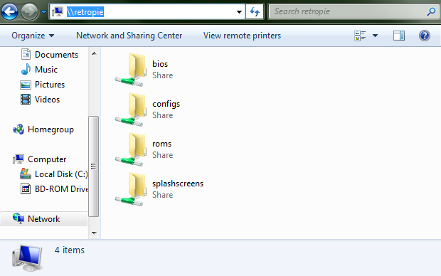

If you don't see the RetroPie Console in your network, try to type **\\RETROPIE** in the explorer address bar. If it doesn't work, go in the RetroPie menu, **Show IP** and type the IP in the explorer address bar, for example **\\192.168.1.100**

Now you can access the **roms** and **BIOS** folders from a Desktop or laptop.

## Add your games

Just download your ROMs, unzip them if they are in one big archive and copy the files into the corresponding Emulator folder. See BIOS and ROM directory LIST for details. The first column shows the accepted rom file formats for a given emulator. The third column shows where rom game files go along with the Bios MD5 value for the emulator.

To refresh the game library, **restart EmulationStation.**

## Arcade games

Arcade games including NeoGeo, MAME and FBA arcade come in sets exclusively and must work with the emulator being used. See the [Retropie Wiki link Managing roms](https://github.com/RetroPie/RetroPie-Setup/wiki/Managing-ROMs) to know which set of roms go with which emulator. Use the Runcommand Prompt to change the emulator used for NeoGeo and Arcade games(MAME, FBA). The default is set to **lr-fba-next**  for NEOGEO arcade gamesand **lr-imame-4all** for MAME Arcade games.

### Get Romset

Find a Romset pack that has the same romset number on the RetroPie [Managing Roms](https://github.com/RetroPie/RetroPie-Setup/wiki/Managing-ROMs) page. Place the pack of roms in the correct Roms folder(See Adding Roms). For example, I found the easiest Mame emulator was lr-imame4all cause the lr- mean the controls work automatically with Retropie. And lr-imame4all uses the 0.37b5 romset looking at the [Managing Roms](https://github.com/RetroPie/RetroPie-Setup/wiki/Managing-ROMs) page again. Clicking the [lr-imame4al](https://github.com/RetroPie/RetroPie-Setup/wiki/MAME) link will show you theromset zip files go in the **RetroPie/roms/mame-mame4all**.

Note that NEOGEO.zip bios files(see BIOS LIST) needs to go in the same roms folder, **RetroPie/roms/mame-mame4all** in this case, as opposed to the BIOS folder like the other emulators.

### Scan Romset

Verify and rebuild the romset following the [wiki link](https://github.com/RetroPie/RetroPie-Setup/wiki/Managing-ROMs#video-tutorial) for using **clrmamepro.**

# ADDING BIOS

14 of the emulators require BIOS files to run Official game ROMs. Search Google for <Name of System> BIOS download. Sites like emuparadise will have BIOS files and game ROMs and should be in your search results. Adding the BIOS is as simple as uploading the listed files to **RetroPie/BIOS** with the exception of Arcade and Neogeo games(See Arcade Games section)

If a Bios filename you downloaded doesn’t match the Bios filename listed in the below table, you can try renaming it to the name in the table.

## Check BIOS(Optional)

A guaranteed way of checking you downloaded the right Bios file is to check its md5 signature to ensure it is the correct one. To check md5:

### Windows

To check a file signature or MD5 checksum, download [MST MD5](http://ec.ccm2.net/www.commentcamarche.net/download/files/mstMD520e.exe)

Install it then drag and drop the bios to create the checksum and display the result into the window.

EXAMPLE : **gba_bios.bin**

[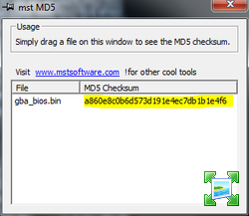](http://www.zimagez.com/zimage/gba2.php)

### SSH RetroPie/ Linux / MacOSX :

Use the md5sum command.

## **BIOS and ROM table**

Add bios files to **RetroPie/BIOS(except MAME and neogeo(see below))**

Rom folders are noted in the third column along with the Bios MD5 value for an emulators bios file.

*** = Requires Keyboard

|  |  |  |
| --- | --- | --- |
| **SYSTEM and ROM FORMAT** | **BIOS File names** | **BIOS MD5 value and ROM LOCATIONS** |
| [3DO](https://github.com/retropie/retropie-setup/wiki/3do)  Accepted File Extensions: **.iso** | panafz10.bin | 51f2f43ae2f3508a14d9f56597e2d3ce  ROMS go in **/home/pi/RetroPie/roms/3do** |
| [Atari 2600](https://github.com/retropie/retropie-setup/wiki/Atari-2600)  Accepted File Extensions: **.bin .a26 .rom** | None required | ROMS go in **/home/pi/RetroPie/roms/Atari2600** |
| [Atari 5200](https://github.com/retropie/retropie-setup/wiki/Atari-800-and-5200)([atari800-rpi](https://github.com/jfroco/atari800-rpi))  Accepted File Extensions: **.a52 .bas .bin .xex .atr .xfd .dcm .atr.gz .xfd.gz** | ATARIXL.ROM, ATARIBAS.ROM, ATARIOSA.ROM, ATARIOSB.ROM, 5200.rom | Atari 5200 ROMS go in **/home/pi/RetroPie/roms/Atari5200**  And Atari 800 ROMS go in  **/home/pi/RetroPie/roms/atari800** |
|  |  |  |
| [Atari 7800](https://github.com/retropie/retropie-setup/wiki/Atari-7800)  Accepted File Extensions: **.a78 .bin** | 7800 BIOS (U).rom | My bios file needed renamed  0763f1ffb006ddbe32e52d497ee848ae  ROMS go in **/home/pi/RetroPie/roms/atari7800** |
| [Atari Lynx](https://github.com/retropie/retropie-setup/wiki/Atari-Lynx)  Accepted File Extensions: **.lnx** | lynxboot.img | fcd403db69f54290b51035d82f835e7b  **/home/pi/RetroPie/roms/lynx** |
| [Atari Jaguar](https://github.com/retropie/retropie-setup/wiki/Atari-Jaguar)  Accepted File Extensions: **.j64 .jag** | None required | **/home/pi/RetroPie/roms/atarijaguar** |
| [Colecovision](https://github.com/retropie/retropie-setup/wiki/Colecovision)***  Accepted File Extensions: **.bin .col .rom .zip** | None required | ROMS go in **/home/pi/RetroPie/roms/coleco** |
| [Game Gear](https://github.com/retropie/retropie-setup/wiki/Game-Gear)  Acceptable File Extensions: **.gg** | None required | ROMS go in **/home/pi/RetroPie/roms/gamegear** |
| [Game Boy](https://github.com/retropie/retropie-setup/wiki/Game-Boy)  Accepted File Extensions: **.gb** | None required | ROMS go in **/home/pi/RetroPie/roms/gb** |
| [Game Boy Color](https://github.com/retropie/retropie-setup/wiki/Game-Boy-Color)  Accepted File Extensions: **.gbc** | None required | ROMS go in **/home/pi/RetroPie/roms/gbc** |
| [Game Boy Advanced](https://github.com/retropie/retropie-setup/wiki/Game-Boy-Advance)  Accepted File Extensions: **.gba** | gba_bios.bin | My file needed renamed  a860e8c0b6d573d191e4ec7db1b1e4f6  ROMS go in **/home/pi/RetroPie/roms/gba** |
| [Intellivision](https://github.com/retropie/retropie-setup/wiki/Intellivision)  Accepted File Extensions: **.int .bin** | exec.bin, grom.bin | ROMS go in **/home/pi/RetroPie/roms/intellivision** |
| [MAME](https://github.com/retropie/retropie-setup/wiki/MAME)  Accepted File Extensions: **.zip** | neogeo.zip | Note the bios and rom files go in  **/home/pi/RetroPie/roms/mame-mame4all**  fbf696477b031f9c186f987b0d751151 |
| [Nintendo 64](https://github.com/retropie/retropie-setup/wiki/Nintendo-64)  Accepted File Extensions: **.z64 .n64 .v64** | None required | ROMS go in **/home/pi/RetroPie/roms/n64** |
| [Nintendo Entertainment System](https://github.com/retropie/retropie-setup/wiki/Nintendo-Entertainment-System)  Accepted File Extensions: **.zip .nes .smc .sfc .fig .swc .mgd** | disksys.rom | ca30b50f880eb660a320674ed365ef7a  ROMS go in **/home/pi/RetroPie/roms/nes** |
| [Super Nintendo Entertainment System](https://github.com/retropie/retropie-setup/wiki/Super-Nintendo-Entertainment-System)  Accepted File Extensions: **.zip .smc .sfc .fig .swc** |  | ROMS go in **/home/pi/RetroPie/roms/snes** |
| [NeoGeo](https://github.com/retropie/retropie-setup/wiki/Neo-Geo)  Accepted File Extension: **.zip** | neogeo.zip | Note this goes in **/home/pi/RetroPie/roms/neogeo**  76f073898cacaf6036a801cc906abad4 |
| [Neo Geo Pocket](https://github.com/retropie/retropie-setup/wiki/Neo-Geo-Pocket)  Accept File Extensions: **.ngp** | None required | ROMS go in **/home/pi/RetroPie/roms/ngp** |
| [Neo Geo Pocket Color](https://github.com/retropie/retropie-setup/wiki/Neo-Geo-Pocket-Color)  Accept File Extensions: **.ngc** | None required | ROMS go in **/home/pi/RetroPie/roms/ngpc** |
| [PC Engine(Turbographx)](https://github.com/retropie/retropie-setup/wiki/PC-Engine)  Accepted File Extensions: **.pce** | syscard3.pce | ff1a674273fe3540ccef576376407d1d  ROMS(**Turbographx**) go in **/home/pi/RetroPie/roms/pcengine** |
| [PlayStation](https://github.com/retropie/retropie-setup/wiki/Playstation-1)  Accepted File Extensions: **.bin .cue .cbn .img .iso .m3u .mdf .pbp .toc .z .znx** | SCPH1001.BIN | 924e392ed05558ffdb115408c263dccf  ROMS go in **/home/pi/RetroPie/roms/psx** |
| [PSP](https://github.com/retropie/retropie-setup/wiki/PSP)  Accepted File Extensions: **.cso .iso .pbp** |  | ROMS go in **/home/pi/RetroPie/roms/psp** |
| [Sega 32X](https://github.com/retropie/retropie-setup/wiki/Sega-32X)  Accepted File Extensions: **.32x .smd .bin .md** | 32X_G_BIOS.BIN  32X_M_BIOS.BIN  32X_S_BIOS.BIN | 6a5433f6a132a2b683635819a6dcf085  f88354ec482be09aeccd76a97bb75868  7f041b6a55cd7423a6c08a219335269e  ROMS go in **/home/pi/RetroPie/roms/sega32x** |
| [Sega Dreamcast](https://github.com/retropie/retropie-setup/wiki/Dreamcast)  Accepted File Extensions: .cdi .gdi | dc_boot.bin  dc_flash.bin | ROMS go in **/home/pi/RetroPie/roms/dreamcast** |
| [Sega SG 1000](https://github.com/retropie/retropie-setup/wiki/SG-1000)  Accepted File Extensions: **.sg .zip** | None required | ROMS go in **/home/pi/RetroPie/roms/sg1000** |
| [Sega Master System](https://github.com/retropie/retropie-setup/wiki/Master-System)  Accepted File Extensions: **.sms** | None required | ROMS go in **/home/pi/RetroPie/roms/mastersystem** |
| [Sega Genesis(Megadrive)](https://github.com/retropie/retropie-setup/wiki/Genesis-Megadrive)  Accepted File Extensions: **.smd .bin .md .iso** | None required | ROMS go in **/home/pi/RetroPie/roms/megadrive** |
| [Sega CD](https://github.com/retropie/retropie-setup/wiki/Sega-CD)  Accepted File Extensions: **.smd .bin .md .iso** | us_scd2_9306.bin  eu_mcd2_9306.bin  jp_mcd1_9112.bin | 854b9150240a198070150e4566ae1290  d8b8b720dea6c6ba25c309ed633930f4  bdeb4c47da613946d422d97d98b21cda  ROMS go in **/home/pi/RetroPie/roms/segacd** |
| [Vectrex](https://github.com/retropie/retropie-setup/wiki/Vectrex)  Accepted File Extensions: **.vec .gam .bin** | None required | ROMS go in **/home/pi/RetroPie/roms/vectrex** |
| [VideoPac Odyssey 2](https://github.com/retropie/retropie-setup/wiki/VideoPac-Odyssey-2)  Accepted File Extensions: **.bin** | o2rom.bin | 562d5ebf9e030a40d6fabfc2f33139fd  ROMS go in **/home/pi/RetroPie/roms/o2em** |
| [WonderSwan](https://github.com/retropie/retropie-setup/wiki/WonderSwan)  Accepted File Extensions **.ws** | None required | ROMS go in **/home/pi/RetroPie/roms/wswan** |
| [Wonderswan Color](https://github.com/retropie/retropie-setup/wiki/Wonderswan-Color)  Accepted File Extensions **.wsc** | None required | ROMS go in **/home/pi/RetroPie/roms/wswanc** |
|  |  |  |

# PLAY!

After you've added your Roms and Bios files you need to restart Emulationstation in order for them to show up. You can restart Emulationstation from the start menu.

# Shutdown

Press **START** and scroll to the bottom and select **QUIT**. Then choose to Restar or Shutdown Emulator Station. The RED console LED light will blink again for 6 seconds. Now press the Power button to turn off the Game console.

# Troubleshooting

## Game Not Starting

A game is not starting, freezes or is generally slow and buggy

### Solutions

1. Make sure if the system needs a bios file it is in place. See the **BIOS and ROM directory LIST** section for the System bios file name and instructions on uploading it.
2. Check to see if other games for that system are working. If no games are working, it could be the rom files that were downloaded don’t work for RetroPie emulators. Find another Rom source. Also, some Roms are titled with Revision letters(for example “Game Title Rev(B)”). Try a later revision to see if that fixes any issues with a particular game.
3. By default, the graphics intensive emulators should be set to play roms at optimal settings. To manually change the resolution settings of a game, see the RunCommand Prompt section.
4. Also try changing the emulator. Again see RunCommand Prompt section. Note: Game saves are isolated between emulators; mean saving a game in one emulator, then changing to another, and pressing load will not load the game saved in the other emulator. A new save will need to be created.

## Updating RetroPie

Updating Retropie and the Jessi Linux firmware can improve performance and add new emulators and features to EmulationStation. However, Linux troubleshooting skills and configuration changes may be required in some cases. It is a good idea to make an image backup before updating. See the [RetroPie Wiki link for updating Retropie](https://github.com/retropie/retropie-setup/wiki/Updating-RetroPie#updating-retropie). Also see the Configuration Utility I made to save and restore configuration files.

## Freezes

### Reset

If a game or Emulation Station freezes, hold the right RESET button on the game console for 2 to 4 seconds to restart the console. If this fails holding the buttons for more than 4 seconds will issue a shutdown command. **The Power button can be pressed at any point the Status lights are all off on the front of the console during a restart or shutdown**.

If the RESET button is not responding, you’ll have to turn off the console for a couple seconds and turn it back on. **If the console isn’t responding to the power button, unplug the HDMI, start the console, plug in the HDMI again, hold the reset button to reset the system and HDMI connection.**

**Note:** If the **POWER** button is press while the lights on the front of the board are on, the SD may get corrupted. However, there is a repair utility that starts with each reboot that runs automatically

## RetroPie Menu

From **EmulationStation** , Scroll through the **Emulator List** until you see the **RetroPie Menu**. From here you can further configure RetroPie. See the Runcommand Prompt section for controls in the **RetroPie Menu.**

# Additional Configuration

## Using Scraper to capture ROM box art and info

Press **START**, select **SCRAPER** from the Main Menu, select the **options** you want and select **SCRAPE** **NOW**.

## SSH Login

To Login to the Linux kernel, with the Console connected to your network,

1. Download putty: <https://the.earth.li/~sgtatham/putty/latest/x86/putty.exe>

2. Enter Retropie as the HostName

3. Click Open

4. If prompterd, Click Yes

5. Login with Username: pi and Password: root

## N64 Emulator Script

The N64 emulator script mupen64plus.sh has been modified to select the appropriate video plugin for a given n64 rom. You can see which games goes with which emulators and make changes to the list by going to \\Retropie\roms\n64\mupenGameList.txt(Open with notepad++). Each line has 3 comma separated fields which are the Game Title, Playable or Unplayable flag, and Video Plugin that runs the game the best.

If PLAYUNTESTED is a line anwhere in mupenGameList.txt, the script will play games that don’t have emulators defined for them. Otherwise it will not load the game. PLAYUNTESTED is set by default.

If PLAYBROKEN is a line in mupenGameList.txt, the script will play games marked Unplayable in field 2. Otherwise, games marked Unplayable will be put in a subdirectory \\Retropie\roms\n64\UNPLAYABLE. PLAYBROKEN is not set by default.

You can change any of these fields based on game performance for your current system. I have pulled the information from the [RetroPie wiki](https://github.com/RetroPie/RetroPie-Setup/wiki/Nintendo-64#rom-compatibility-list-feel-free-to-contribute) and my own game testing. Emulators also may need changed after an update as performance can change. As of this writing, 7/22/2016, the best candidates to pick from the Runcommand Prompt are Glide, gles2n64, gles2rice, lr-mupen64plus and videocore in order of most likely to work.

Note: Any game in the list that has a Video Plugin defined in Column 3, will take precedence over whats set in the Runcommand Prompt.

### Notepad++

In **Notepad++**, be sure to set **Edit menu -> EOL Conversion -> Unix**. Otherwise, viewing .txt files from Windows explorer will add unwanted Control characters to the end of each line. In case that happens, run **sudo dos2unix /home/pi/RetroPie/roms/n64/mupenGameList.txt** from SSH.

## RetroPie Configuration Utility

The RPConfig.sh script in /opt/retropie/configs/ can be used to save, load and compare Configuration file sets. It is advised to use this utility to save a working configuration before updating or making changes to the system files. Use the compare flag to see new changes to files after an update. This differs from [Backing up the image show here](https://github.com/retropie/retropie-setup/wiki/Updating-RetroPie#making-a-backup-option-1), which will restore a complete backed up image of the operating system.

Usage:

Cd /opt/retropie/configs/

Sudo ./RPConfig.sh <run option>

Run options are:

-s Store current RetroPie configuration

-r Read stored configuration to current RetroPie install

-c Compare stored configuration and current RetroPie install configuration files

-x Extract current archived config

-a Archive current stored RetroPie config

# Contact Email

Dev303102@gmail.com